
MIS INTERNATIONAL SCHOOL, BALEWADI

SESSION 2025-26

‘Ek Ped Maa Ke Naam 2.0’

Tree Plantation Activity Report
To commemorate World Environment Day, MIS International School, Balewadi organized a meaningful and heartwarming tree plantation activity under the theme "Ek Ped Maa Ke Naam 2.0".
The initiative aimed to not only raise awareness about environmental conservation but also to honor the invaluable role of mothers by planting a tree in their name.
As part of this initiative, students, along with their mothers, actively participated by planting a sapling either at home, in their society, or in a nearby open space. The unique concept beautifully blended environmental stewardship with a personal emotional connection, fostering a sense of responsibility and gratitude among students.
Parents enthusiastically shared photographs of the plantation activity with the school. The images reflected joyful moments of students and their mothers bonding over nature, nurturing the saplings with care and affection. These photos have been compiled and showcased on the school’s digital platforms to inspire the wider community.
This green initiative not only promoted eco-consciousness but also strengthened the bond between the students and their mothers and Mother Nature, reinforcing the idea that small actions can lead to a big impact for the planet.
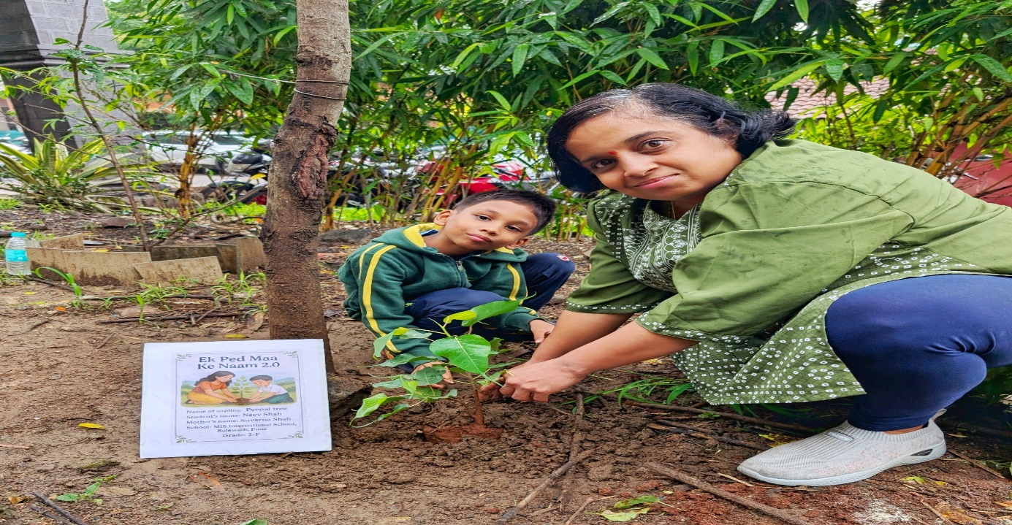
MIS International School is proud to contribute towards a greener tomorrow and thanks all parents and students for their active involvement in making Ek Ped Maa Ke Naam a resounding success.

